3P PF 320 Series Pump Controller

Installation and Operation Manual

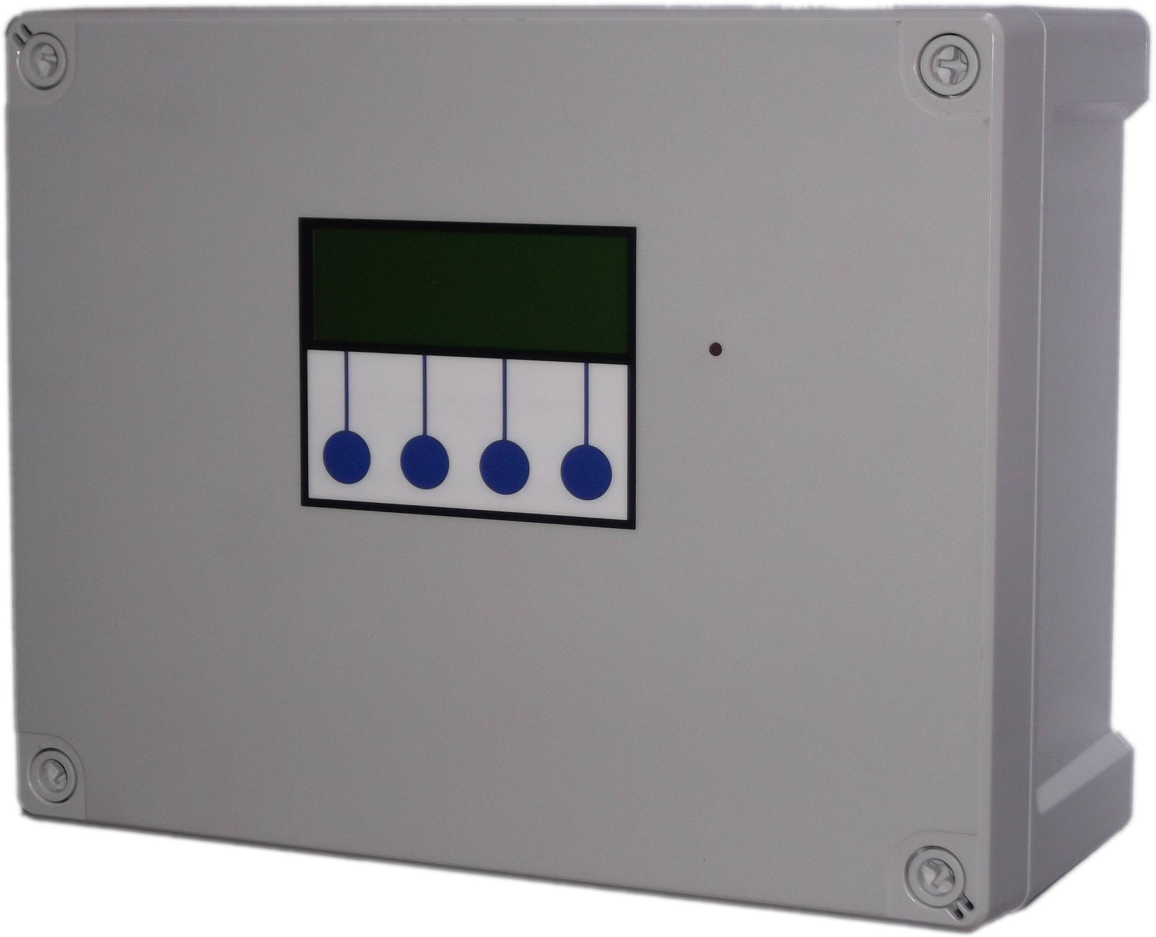
Table of Contents
Installation 3
Safety 3
Installation Constraints 3
Control Panel Mounting 5
Mains Power Connection 6
Pump Power Connections 6
Supply Tank Level Sensor and connection 6
BMS connection 7
Operation 8
Safety Considerations 8
Description of Operation 9
Control Panel Operations 10
Startup Screen Menus and Functions 11
Tank Level Display 11
Accessing the Menu Options 11
Menu Options, Button 1 - Configuration and Diagnostics 11
Tank Menu 12
Reset water level calibration in % (Reset Lvl %) 12
Minimum water Level Control (Min Lvl) 12
Pump Control (Pump Ctrl) 12
Pump Selection (Pumps) 13
Pump Pressure Adjustment 13
Diagnostics Menu 14
Input Monitor 14
Output Testing 14
Read Stored Fault Codes 15
Fault Code List 15
Clear Stored Fault Codes 16
Run 16
Troubleshooting 17
Fuse Listing 20
Inputs (left to right) – Con1 20
Pressure Sensor Inputs (left to right) 21
BMS Output 21
Pump Control Outputs (left to right) 21
Upgrades and Modifications 21
Specifications 22
Control Panel 22
Tank Level Sensor 22
Line Pressure Sensor 22
Switched Outputs (pump control) 22

Installation

Safety
Mains Voltage – There are exposed electrical conductors inside this appliance. This appliance must be installed and serviced by a competent electricical technician to the current requirements of BS7671 and IEEE recommendations. Before servicing this appliance, normal safe isolation procedures should be implemented.

Do not touch the PCB while energised, it carries mains voltage.

Do not touch any connection terminals while energised.

Do not attempt to service electrical objects when wet, or in a wet or high humidity environment.

If the housing of the control panel, or any cabling becomes damaged, you must shut down and securely isolate this appliance immediately.

You must connect this appliance to a grounded 3 wire supply, protected by suitable overload protection. Connected pumps and solenoids are earthed via the control panel, and may otherwise become live.

If the power cables are damaged, either to of from the controller, isolator, or pumps then shut down and isolate this appliance.

The combined loading of pumps must not exceed 20A using the supplied mains flex. Contact the manufacturer for advice if you need to exceed this rating.

Do not attempt to repair any part of the circuit board. Refer to the manufacturer for advice.

Installation Constraints
Unlike other pressure controllers, the 3P PF320 does not contain pipework which connects directly to the pump, but uses an external pressure sensor. This means you can install the control panel either upon a pump set or anywhere you wish within the building. You can also run a pump and break tank with the pumps submerged (the most efficient possible method).
You will need to consider the following constraints,

The control panel cannot be mounted outside, it is splash proof not weather resistant.

Voltage drop will affect the cable size needed to take power to your pumps. Over very long runs, you may find it more economical to install contactors near to the pumps, allowing you to control the pumps with a sensible cable size. It is strongly recommended that you calculate voltage drop for cable runs in excess of 20m. Failure to do so may result in cable overheating, conductor migration, brownouts, and risk of fire.

Pressure transmitter cable must be of a special type incorporating a vent tube to equalise the pressure within the transmitter to atmospheric pressure (3P part no. IRVENT). Conductivity probe cable is 2 core 0.5mm2 unshielded. It is recommended to use shielded vented cable to extend the probe beyond 20m.
Note – it is recommended that you earth the shielding on cables (where present) to an earth terminal within the controller if such cables are to be run near power cabling. Do not earth to DC 0v as the DC power supply is isolated and will not function as a ground.

Control Panel Mounting
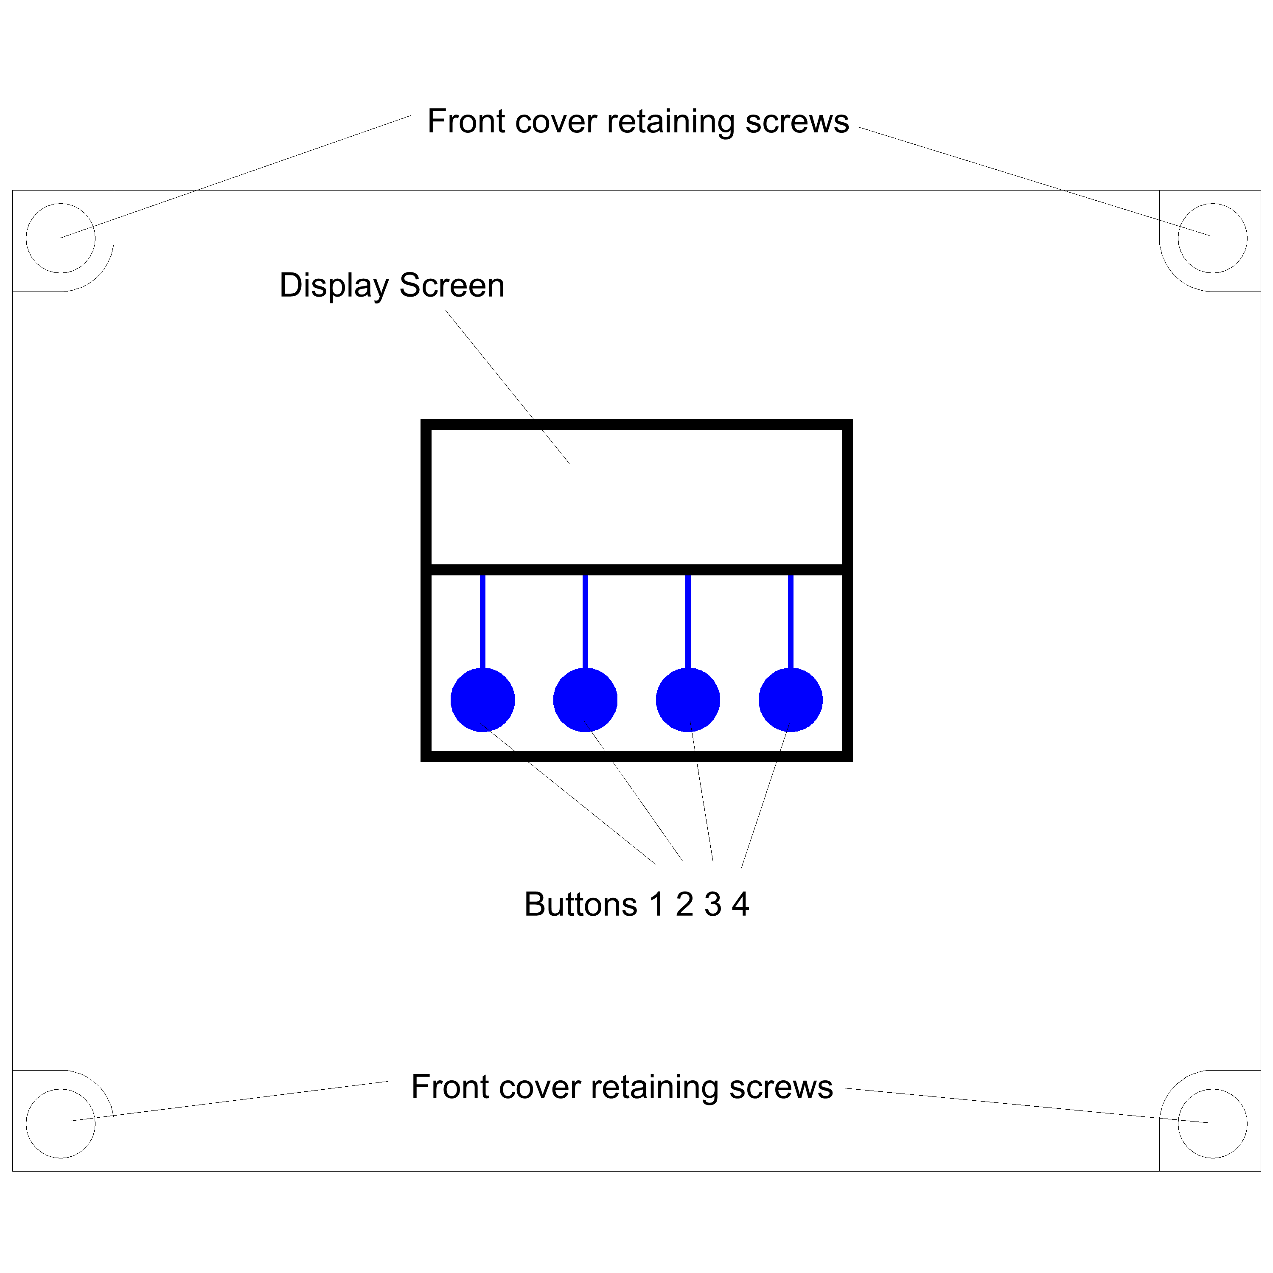If your control panel has been supplied with wall mounting brackets, these will attach to the rear of the panel and allow easy wall fixing without having to open the panel. If not then follow the instructions below.
Having selected a suitable location, unlock the 4 locking screws on the corners of the front cover and withdraw the front panel. The LCD display, buttons and alarm LED are connected to the PCB. Remove and replug these cables afterwards if necessary in accordance with the diagram.
The 4 screw mounting holes are located on the main enclosure in recesses adjacent to the front panel mounting holes. Mark drilling points on the wall accordingly. Withdraw the casing from the wall and drill holes appropriate for your selected fixings.
To mount the panel on a pump set manifold or bracket, we recommend adhesive fixing or similar, without breaching the housing of the panel. If you choose to drill the housing and mount with screws, rivets etc then you will have to figure this out yourself but please ensure electrical isolation between the rear of the PCB and any fixings used.

Mains Power Connection
The power supply to the control panel enters via a cable gland on the bottom right of the housing. A 20A supply cable is provided with the panel. If you need to change this, insert the cable, connect to the incoming power terminal on the right of the PCB, and tighten the cable gland.

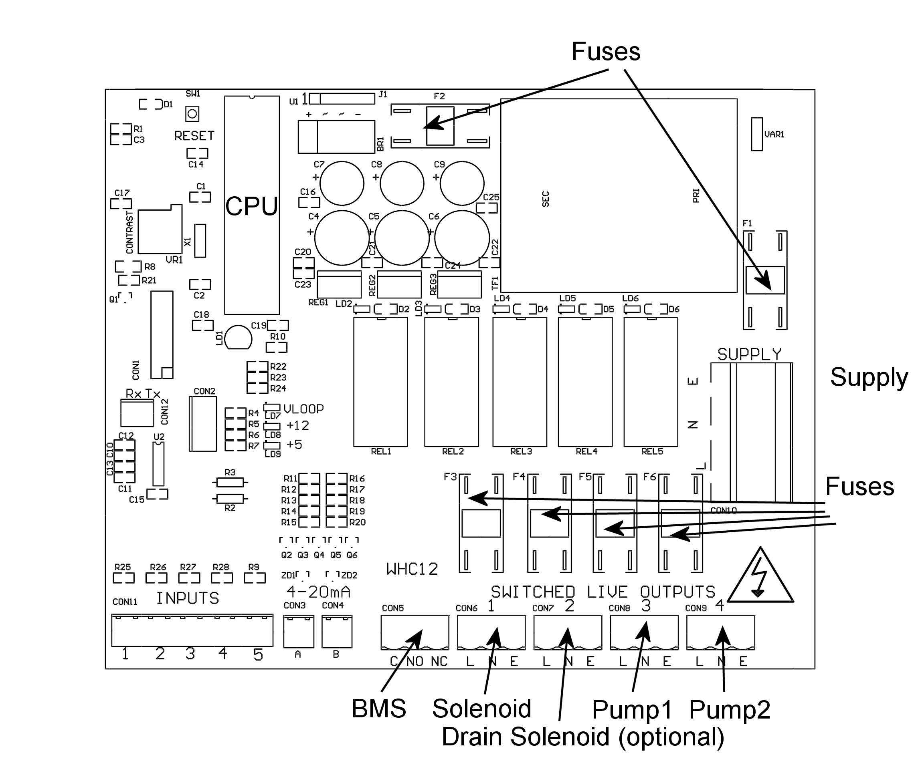

Pump Power Connections
Pumps are powered from the rightmost green terminals on the lower right of the PCB. From left to right terminal 4 supplies pump1, and terminal 5 supplies pump2. The terminal blocks are socketed and can be withdrawn from the PCB for ease of access.

Note – If cables need to be routed into the controller other than with the cables glands fitted, ensure they enter the bottom of the casing and do not cross over the circuit board. If necessary use trunking to route cables appropriately.

Supply Tank Level Sensor and connection
Connect the tank level sensor as follows
Pressure Transmitter (PF320) - Connect to the socket on the underside of the control panel.
The pressure transmitter should be lowered onto the bottom of the water tank and not suspended.

Conductivity Probe – (PF120) – Connect to the socket on the underside of the control panel. Suspend at the height required to prevent air intake to the pumps.

Float Switch – (PF220) – Connect the 2 wires than form a closed contact when the float switch is in the up position to pins 1 and 2 on the 10pin input block in the lower left corner.

As the conductivity probe / float switch cannot determine the actual water level only the switch point, it must be attached within the tank to hang at the intended switching point. You should ensure this is at least several inches above the top of the pumps (if the pumps are submerged) to prevent pump damage during cold weather.

BMS connection
The BMS connection provides a non-voltage relay capable of switching any 230V source up to 10A. Three contacts are provided, Common, NO and NC. Connect your live conductor from the BMS system to Common, and output will be switched to NC in the absence of an alarm condition, switching to NO upon an alarm.

Operation

Safety Considerations
Mains Voltage – There are exposed electrical conductors inside this appliance. This appliance must be installed and serviced by a competent electricical technician to the current requirements of BS7671 and IEEE recommendations. Before servicing this appliance, normal safe isolation procedures should be implemented.
Do not touch the PCB while energised, it carries mains voltage.
Do not touch any connection terminals while energised.
Do not attempt to service this item when wet, or in a wet or high humidity environment.
If the housing of the control panel becomes damaged, you must shut down and securely isolate this appliance immediately.
You must connect this appliance to a grounded 3 wire supply, protected by suitable overload protection. Connected pumps and solenoids are earthed via the control panel, and may otherwise become live.
If the power cables are damaged, either to or from the controller then shut down and isolate this appliance.
The combined loading of pumps and solenoids connected to this appliance must not exceed 20A using the supplied mains flex. Contact the manufacturer for advice if you need to exceed this rating.
Do not attempt to repair any part of the circuit board. Refer to the manufacturer for advice.

Description of Operation
The 3P PF series is an advanced booster pump / well pump controller, designed to manage either a single pump or a pair operating in a duty standby / duty assist arrangement. Water pressure in the discharge line is rapidly monitored, and pump(s) activated accordingly to maintain pressure between high and low pressures which can be selected by the operator. In this manner the pressure of the pump set can be adjusted at any time to suit either the optimal efficiency of the pumps, or suit the ideal pressure and flow requirements of the installation. In addition a high pressure alarm will shut down the system in the event of an overpressure condition, such as inadvertently connecting in series with another pump or if a high pressure shock wave is detected, and a low pressure alarm indicates a failure or dry running, and will shut it down within 10 seconds and revert to the remaining pump if connected. Both alarm set points can also be adjusted.

Water in the break tank or well is monitored by an accurate pressure sensor. Water level is displayed, and a minimum shut-off level can be adjusted to prevent dry running of the pumps.

There is no need for float switches and no need to enter the break tank to make adjustments to sensor levels, no need for pressure control valves or throttling. All adjustments can be set on the control panel.

Faults which may occur are logged in memory and the system will either continue wherever possible, stopping only for critical errors such as a failure of both pumps or a system over-pressure. A BMS output allows integration with other fault management systems, or connection to alarm sirens or strobes.

All connection terminals except the mains supply cable are socketed for quick removal and servicing. The main processor/memory is DIL socketed for easy software upgrades, and the PCB can be removed rapidly for exchange.

Durability is enhanced with an IP65 enclosure (can be sealed to IP68), dirt/water resistant membrane keypad, individually fused outputs, hinged lid, overvoltage protection, oversized supply power terminals and transformer/smoothing, and brown-out tolerant software. In the event of a power surge, fuses are ceramic with high (1250A) rupture current and MOV protection/track layout is designed to increase repair probability. PCB repairs are available and most component parts are stocked by 3P Technik UK.

Control Panel Operations

Startup Screen Menus and Functions
Upon first applying power, the LCD panel will display a startup logo followed by automatic calibration of the tank level sensor for approximately 3 seconds, and then immediately commence operation. The main screen displays the following screen (values shown will be different)

Level 94%
Pressure 2.5 bar
Pumps off
Menu Stop

Showing,
Supply Tank Level Display in %
Delivery Line Pressure (in bar)
Pump Status (on/off) per pump
Menu Options

Note that the function of the 4 buttons are not fixed, but relate to the menu option shown above. There are no hidden or “engineer” functions, no combined keypresses, and no push and hold operations.

Tank Level Display
The current supply tank level will be shown in %, and is measured by a submerged pressure sensor at the bottom of the tank. The scale is adjusted automatically as the control panel learns the maximum and minimum water levels within the tank, with 0% being the minimum level allowed (pump cut-off level) and 100% being the highest water level detected. Initially therefore, the display may be inaccurate until the tank is full for the first time.

Accessing the Menu Options
The last line of the display always shows up to four menu options, which can be selected by pressing one of the four corresponding buttons beneath the display. The menu options displayed will change as you enter different areas of the software.

Menu Options, Button 1 - Configuration and Diagnostics

Main Menu

Tank
menu Diags Run

All other options relating to configuration and diagnostics, can be found via Button 1 from within the status screen. Whilst in this area all operation is halted while parameters are being set by the operator. To exit press “run”.

Tank Menu

Supply Tank Menu
Reset Set
Lvl min Pump
% lvl ctrl Exit

All options under this menu are related to operations within the water tank.

Reset water level calibration in % (Reset Lvl %)
Selecting this option will cause the control panel to disregard previously learned water depths within the water tank. The system will then re-learn the maximum water level over time. When selected the following message confirms calibration has been reset.

Resetting tank
level sensor...

Minimum water Level Control (Min Lvl)
This setting allows you to change the level at which the water tank is considered empty, and pumping will cease to prevent dry-running and preserve enough water to protect submerged pumps against frost. The default level is 60cm.

NOTE – it is essential that you allow sufficient depth of water above the pump to protect the pump from frost during the winter if the tank is situated externally, we would suggest a minimum of 20cm above the top of the pump.

Supply tank minimum
level adjustment
Minimum – 60cm
+ - Exit

Pump Control (Pump Ctrl)
This is a submenu containing functions related to pump selection and pressure. Providing 2 sub-menus as shown.

Pump Control Menu

Pressure
Pumps Exit

Pump Selection (Pumps)
Here you can select which pump you would like to use. The default setting is Pump 1. If your system has 1 pump only then you should leave it on this setting.

Pump Selection
Twin pump operation
+ - Exit

If you have a second pump fitted. You can choose to either leave it as a redundant spare, or to run in twin pump mode (duty assist with pump alternation). There are 2 options for twin pump mode, in Twin pump operation both pumps will function as duty standby / duty assist, with alternation per startup, and anti-blocking cycle / pump test performed at intervals. Twin pump operation, no autotest/ABS will function in the same mode but without periodic pump tests / anti-blocking cycle, providing a very small decrease in energy consumption but decreased fault detection. As the saving in energy consumption is extremely minimal, this mode is not recommended.

In the event that a pump fails to produce sufficient pressure, a warning will be activated, and the pump abandoned. The system will now run in single pump mode using the remaining pump. The BMS will activate during pump failure, and will discontinue once a working pump has been found. In the event that a second pump is also faulty, or is not fitted, the system will cycle between pumps in attempt to restart an available pump which may have an intermittent fault, if no success the system will cease operation and report a critical fault. At this point the BMS alarm is continuously active, alerting the operator to this condition.

Pump Pressure Adjustment
The default setting is Pump1 cuts in at 1.5 bar and Pump2 cuts in at 2 bar, both pumps cut out at 3bar (also adjustable). During pump pressure adjustment the following screen is displayed.

Pump 1 – Pressure
Min Max
1.5 3.0 bar
- + Min Exit

Buttons 1 and 2 lower or raise the pressure, while button 3 cycles between setting Min or Max (cut-in and cut-out pressures). The pressure you select will of course depend on the height difference between the pressure sensor and point of use, and the required pressure. The pressure at the point of use will decrease by 1 bar per 10m of lift, and so this should be taken into account when setting the pump pressure.

It is advisable to set both pump to cut in at different pressures. Although the control panel will allow the same pressure to be set on both pumps, this would result in unnecessary use of both pumps, and unnecessary inrush current which may affect nearby devices on the same supply circuit by momentarily reducing available voltage.

To attain maximum efficiency, you should select a pump set which can deliver the maximum required pressure within the efficient zone of it's performance curve (before the curve levels off). As centrifugal pumps are less efficient at their maximum rated pressure, and as we have full control of the cut-out pressure, it makes sense to select a pump on the premise that you will be using it with it's most efficient performance characteristics.

The pressure vessel(s) on the system should be charged to or just below the lowest cut-in pressure (min) of the pumps, i.e. the lowest minimum pressure you have set. Do this with the discharge line de-pressurised (turn off the system, open a tap).

Diagnostics Menu
Once selected via Button 3, here are three buttons or menu options available under the “Diagnostics” menu.

----Diagnostics-----

Inputs Faults
Outputs Exit

Input Monitor
Selecting this option shows the status of all sensor inputs to the controller. The following information is displayed.

Probes 11111 --(this function is unused on PF Series)
Lvl Probe 180cm
Line Pres 3.1 bar
Exit

Line 1, Switched inputs 1 to 5 (used on rainwater harvesting/tank control models only)
Line 2, Tank level sensor shown in %
Line 3, Delivery line pressure

Note that tank level here is shown in cm not %. The level shown here is not subject to calibration and displays the actual tank level rather than a proportional reading.

Output Testing
This option allows you to fire the 230v outputs of the controller.

Output Testing
00
Push Buttons...
Exit Pump1 Pump2
Button 1 – Exit
Button 2 – Unused
Button 3 – Pump1
Button2 – Pump2

Note – While testing the pumps, the overpressure alarm setting, pump failure pressure and other alarm functions are over-ridden. If system pressure is increased beyond the overpressure alarm setting a fault may be logged when operation is resumed. If this occurs, release system pressure and switch the controller off and back on to resume normal operation.

Read Stored Fault Codes
This RainForce Controller is equipped with Advanced Fault Tracking, and unlike other controllers will remember the last 10 faults that have occurred (even after power outage). This gives the Operator much greater insight into any fault, should one occur, as the fault history can be examined, and an informed judgement made.

Fault Code 1 – 255

Next Prev Clear Exit

Buttons 1 and 2 cycle forward or backwards through the 10 memory locations which store the fault codes

Fault Code List

- Tank Probe Fault (PF120 only)
- Pump 1 Insufficient
- Unused
- Unused
- Unused
- Tank Level Sensor Fault
- Discharge Line Pressure Sensor Fault
- Pump 2 Insufficient
- Unused
- Unused
- Pump 1 Disabled – Changed to Pump 2
- Pump 2 Disabled – Changed to Pump 1
- Both Pumps Faulty or Insufficient
255. No Fault

The menu options now available are

Clear Stored Fault Codes
Selecting this option clears all stored fault codes from the controllers memory, and is confirmed by the following message.

Faults cleared…

Run
Resume operation. Select this to return to the main operational display when configuration/diagnostic is finished.

Troubleshooting
Refer to the Safety instructions. No electrical works should be carried out other than by an appropriately qualified Electrician. Permits to work may be required at local site conditions. If in any doubt, consult your system supplier.

Problem | Probable Cause | Solutions
No Power – controller dead – no backlight on LCD | No power supply from distribution board  Fuse failed  PCB damaged | Check 240 vac 50hz supply at power input terminals.  Check Fuse F1  Replace PCB, contact manufacturer.
Backlight on – no display – no operation | CPU chip missing  CPU chip badly inserted or bent pins  CPU chip wrong way round  CPU chip faulty  PCB damaged | Insert CPU  Insert CPU correctly or replace if necessary  Remove and re-insert correctly  Replace CPU  Replace PCB, contact manufacturer.
Controller Frozen – operates normally but keypad unresponsive | Keypad not connected or connected wrongly | Check connection
Controller Frozen – does not operate normally | CPU or oscillator damaged | Replace CPU, if no success replace PCB
Conductivity probe appears not to function (PF120) | Not connected  Cable damaged  Rainwater conductivity abnormal (chlorine, salt, etc) | Check connection to control panel  Bridge probe end and continuity test. Replace if and as necessary  Swap probe for float switch to accommodate non-standard environment
Float switch appears not to function (PF220) | Not connected  Cable damaged  Float not constrained properly  Float faulty | Check connection to control panel  Test continuity, replace if necessary  Tie float in tank such that it switches up/down around switch point  Replace
Tank level sensor does not function (PF320 - error 6) | Not connected  Connected wrongly  Sensor faulty  Input circuit faulty | Check wiring to controller  Check wiring polarity and correct if needed  Test with loop calibrator, replace sensor if necessary  Test with loop calibrator, replace PCB if necessary
Tank Level sensor reads incorrectly | Cable vent tube blocked or sealed  Wrong sensor specification installed  Sensor faulty | Ensure vented section of cable terminates to atmospheric pressure  Replace with original OEM spec part  Test with loop calibrator, replace if necessary
Line pressure sensor does not function (error 7) | Not connected  Connected wrongly  Sensor faulty  Input circuit faulty | Check connection at control panel  Check wiring polarity and correct if necessary  Check with loop calibrator and replace if necessary  Test with loop calibrator, replace PCB if necessary
Line pressure sensor reads incorrectly | Wrong sensor specification installed  Sensor faulty  Input circuitry faulty | Replace with original OEM spec part  Test with loop calibrator, replace sensor if necessary  Test with loop calibrator, replace PCB if necessary
Pump 1 Insufficient or Faulty | Pump not connected  Pump cannot keep up with demand  Pump faulty  (this fault can show temporarily when filling a large header tank for the first time, in which case it should be ignored). | Check wiring  Replace with correctly sized pump  Replace pump
Pump 2 Insufficient or Faulty | Pump not connected  Pump cannot keep up with demand  Pump faulty  (this fault can show temporarily when filling a large header tank for the first time, in which case it should be ignored). | Check wiring  Replace with correctly sized pump  Replace pump
Pump 1 Disabled | Pump not connected for over 20 minutes  Fuse failed on output  Pump cannot keep up with demand for over 20 minutes  Pump faulty (most likely) | Check wiring  Check and replace if necessary  Replace with correctly sized pump  Replace pump
Pump 2 Disabled | Pump not connected for over 20 minutes  Fuse failed on output  Pump cannot keep up with demand for over 20 minutes  Pump faulty (most likely) | Check wiring  Check and replace if necessary  Replace with correctly sized pump  Replace pump

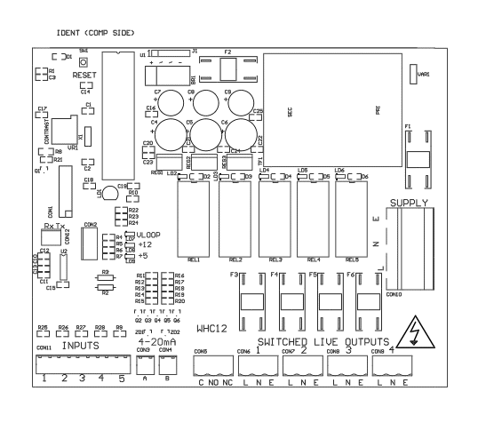

Fuse Listing

F1 – 500mA 20mm
F2 – 1A 20mm
F3 – 10A 20mm
F4 – 10A 20mm
F5 – 10A 20mm
F6 – 10A 20mm

All fuses are ceramic with 1250A rupture current, this is to ensure minimal damage in the event of a high current surge such as a lightning strike to the pump set.

Inputs (left to right) – Con1

1 – Water tank conductivity probe or float switch (PF120/220)
2 – unused
3 – unused
4 – unused
5 – unused

Pressure Sensor Inputs (left to right)

Con3 (left) – Water tank level sensor (PF320)
Con4 (right) – Line pressure sensor

BMS Output

Type – Non contact relay
Terminals – Common, Normally Open, Normally Closed
Power Rating max 10A 230Vac

Pump Control Outputs (left to right)

1 – Unused
2 – (reserved for future upgrade)
3 – Pump1
4 – Pump2

Upgrades and Modifications
The following parts of the system can be upgraded at any time without any modification to the control panel.

Replacement/upgrade of pump(s)

Note – there is no need to reprogram or adjust the control panel settings when replacing a pump with one of a different power output or consumption. Diagnostic functions are not dependent on current monitoring.

Installation of 3 phase pump(s) via external contactor/relay.

Software upgrade by either on-site reprogramming, or by CPU replacement. Reprogramming is unlikely to ever be necessary, but is provided for to allow for custom software to be retrofitted to the control panel. It is carried out by an approved engineer via an on-board programming port, or via replacement of the CPU. The CPU is socketed in a 40pin DIP socket for ease of replacement.

When replacing the CPU, always use a proper DIP Extraction Tool, and follow the instruction provided with the replacement CPU.

Specifications

Control Panel

Dimensions 240mm x 190mm x 110mm
Weight
Supply Voltage 230-240 Vac 50Hz
Power Consumption (standby) 7W
Operating temperature range 0 to 40 degrees celsius
Ingress protection IP66
Protection Class 1

Tank Level Sensor

Type Pressure Transmitter 2 wire
Measurement Range 0-0.6 bar
Input 8 to 30 Vdc
Output 4-20mA

Line Pressure Sensor

Type Pressure Transmitter 2 wire
Measurement Range 0-10 bar
Input 8 to 30 Vdc
Output 4-20mA

Switched Outputs (pump control)

Voltage 230-240vac 50hz (exact voltage as supply voltage)
Current 10A (per output)

